OPG applies for operating license for BWRX-300 SMR
Thursday, 2 April 2026
Canada's Ontario Power Generation has submitted its application for a licence to operate the first BWRX-300 small modular reactor at the Darlington New Nuclear Project.

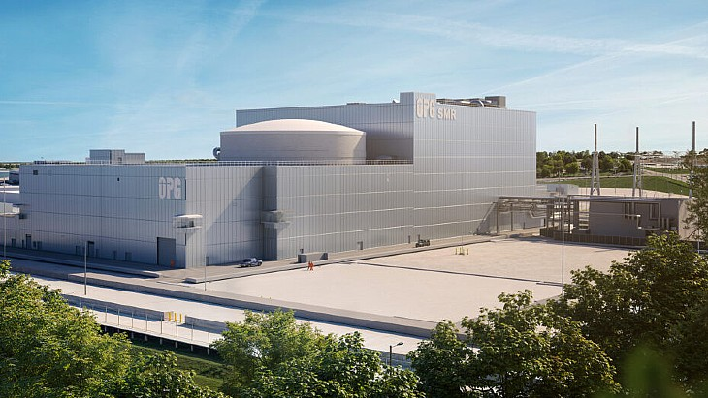
An illustration of how the first BWRX-300 could look (Image: OPG)
The application by Ontario Power Generation (OPG) is for a 20-year licence to operate what looks set to be the first small modular reactor (SMR) in a G7 country, as well as an associated low- and intermediate-level waste storage structure.
The Canadian Nuclear Safety Commission (CNSC), confirming the receipt of the application, said: "The application for a licence to operate is subject to a decision by the Commission following a public hearing, to be announced at a later date."
A licence to operate will be needed to complete commissioning and safely operate the reactor once construction is completed, OPG said.
OPG already holds a construction licence for the site, which has three regulatory hold points (RHP). The first of these was the installation of the reactor building foundation, a hold point which was lifted on Monday.
Ramzi Jammal, CNSC Executive Vice-President and Chief Regulatory Operations Officer, said in a letter to OPG: "The Canadian Nuclear Safety Commission staff assessment of OPG’s submission, as well as all supporting documentation, concludes that OPG has met all the pre-requisites established by the Commission to remove RHP-1."
The removal of this hold point means OPG "can place the foundation for the reactor building and commence civil construction of the reactor building structure, internal civil structures, and internal reactor building systems and components".
The next hold point will be the installation of the reactor pressure vessel.
Background
GE Vernova Hitachi Nuclear Energy's BWRX-300 is a 300 MWe water-cooled, natural circulation SMR with passive safety systems that leverages the design and licensing basis of GE Vernova Hitachi Nuclear Energy's US Nuclear Regulatory Commission-certified ESBWR boiling water reactor design and its existing, licensed GNF2 fuel design.
The Darlington New Nuclear Project will be the first new nuclear build in Ontario in more than three decades. OPG received a Licence to Construct the first of four planned BWRX-300s at Darlington from the CNSC in April 2025. The following month the Province of Ontario approved the CAD20.9 billion (USD15 billion) budget and the start of construction for the first of the proposed four SMRs at the site.
Ontario's Ministry of Energy and Mines said its approval of OPG's plan would create up to 18,000 Canadian jobs and inject CAD500 million annually into the Ontario economy, with the construction, operation and maintenance of the four units set to add CAD38.5 billion to the country's GDP over 65 years. It said the provincial government and OPG have worked together to ensure that 80% of project spending goes to companies in Ontario.
Site preparation works began in the autumn of 2022, and several long-lead items, including the reactor pressure vessel, have already been procured. The plan is to connect the first unit to the grid by the end of 2030.

